**Big Data Programming Project Increment 1**

**Dataset:**

We are collecting twitter data using Twitter batch API using twitter developer account credentials with Republicans and Democrats as keywords. All tweets are in CSV format. We collected about 3 million tweets which is about 450 Megabytes. It has description of a tweet like user_description, user_location, coordinates, user_name, user_created, user_followers(follower_id, created), retweet_count, polarity, subjectivity. We are collecting using batch API and able to download 4kb per second in which we are filtering for keywords like Democrat supporters, Republican supporters.

**Block-diagram:**

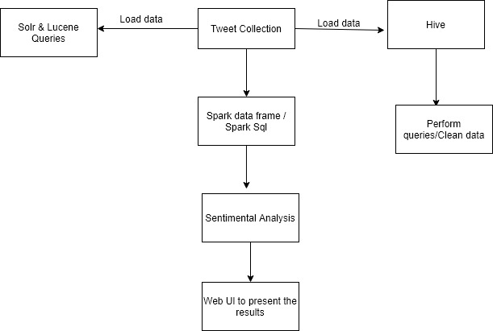

We created a Twitter Developers API account, then we got API tokens and credentials with which we got the tweets using tweetpy and twitter streaming API in python and stored tweets into sqlite db.Imported the queries into csv file using python. Collected around 4 million tweets. Imported the csv file into HDFS. Visualized the csv data file in Hue. Processed the dataset using Hue by creating database& database table in hue and implemented various queries to get specific information on tweets. For next phases we are going to Implement solr& lucene on the data, create spark dataframes on CSV file and implement various transformations and actions on dataframes. We are also going to implement Spark sql, and query the data from dataframe. we will implement sentiment analysis on the data.

**Analysis of Increment-1:**

We created a Twitter Developers API account, then we got API tokens and credentials with which we got the tweets using tweetpy and twitter streaming API in python and stored tweets into sqlite db.Imported the queries into csv file using python. Collected around 4 million tweets. Imported the csv file into HDFS. Visualized the csv data file in Hue. Processed the dataset using Hue by creating database& database table in hue and implemented various queries to get specific information on tweets.

**Implementation:**

**Collected tweets:**

* Got developer access from twitter, then created an app to use their APIs.
* Using tweepy and twitter streaming API collected tweets in python and below is the code.

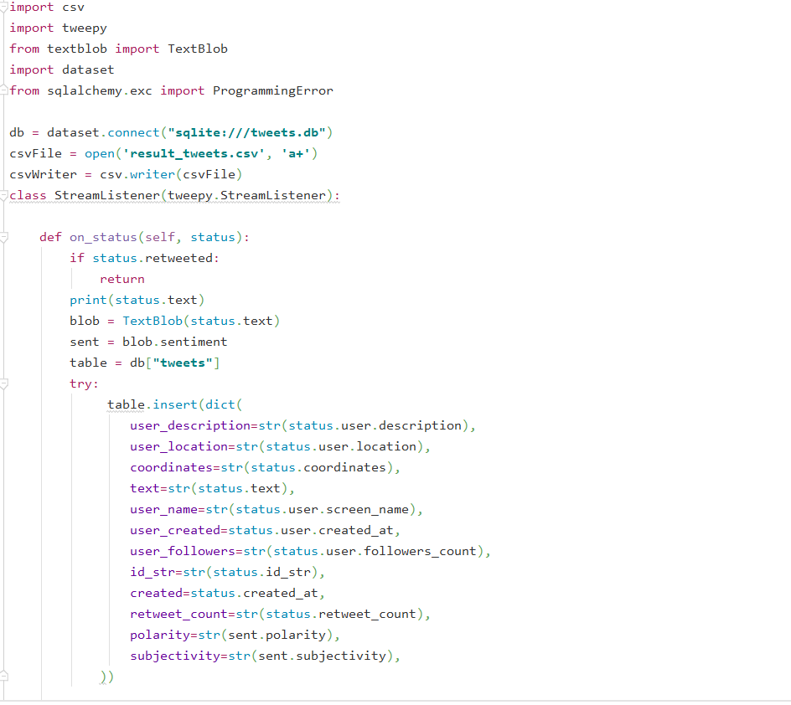

* Storing the tweets into sqlite db

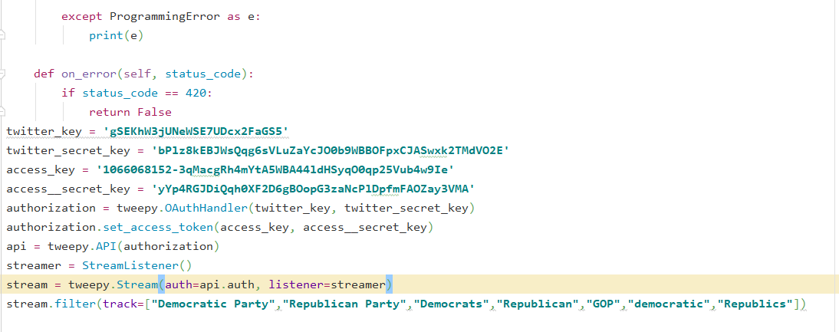

* After storing the tweets into sqlite db importing them into csv file using below code.

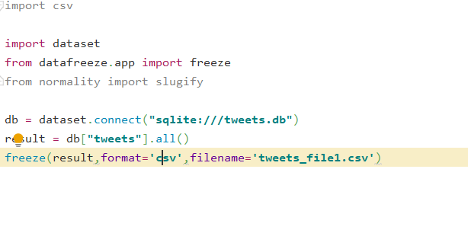

* Collected around 40 million tweets.
* Imported the file into hdfs.

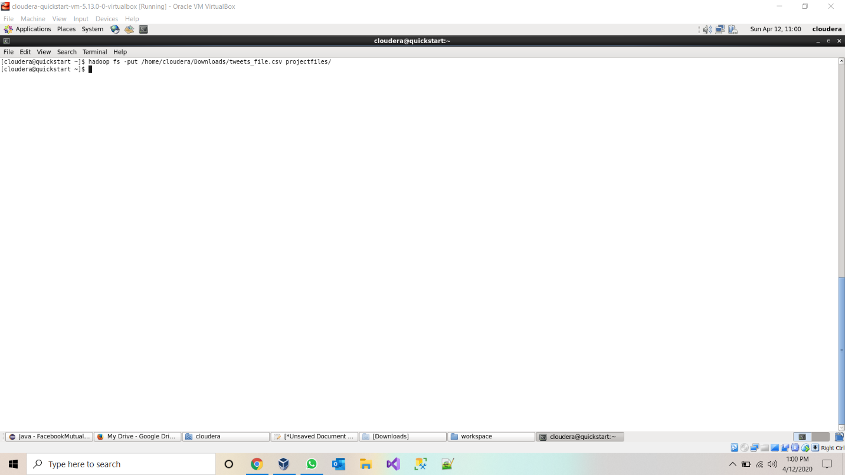

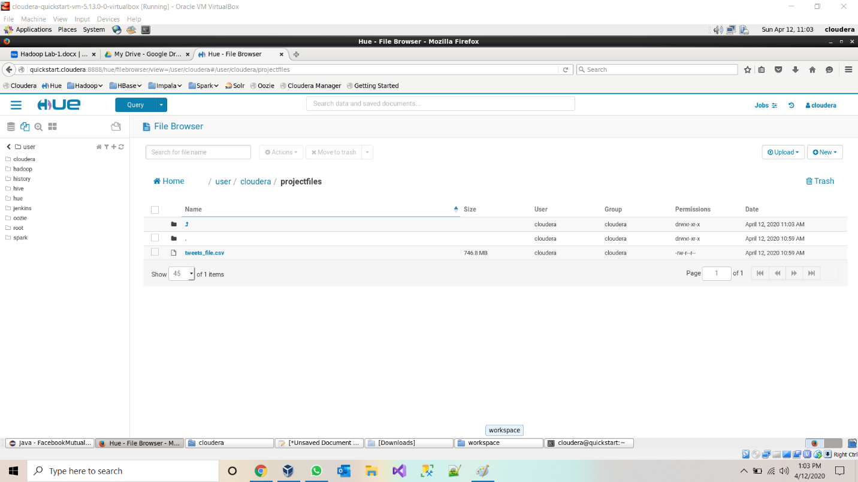

* Created a database and database table in hive and loaded the data into hive table.

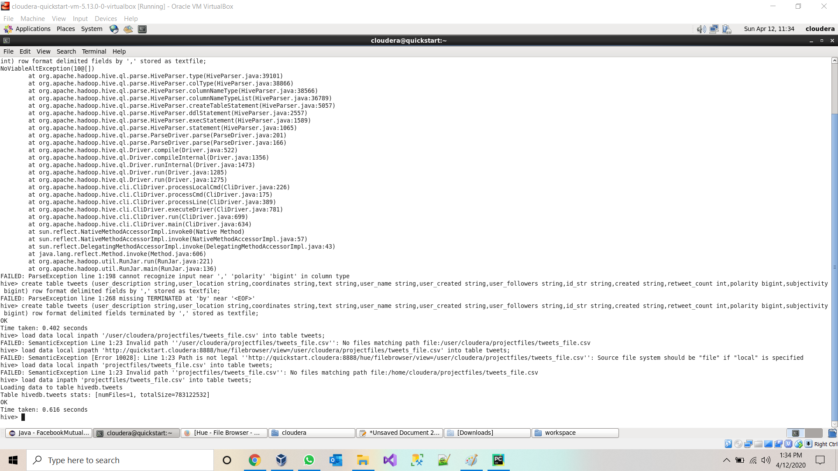

* Viewing data table in Hive.

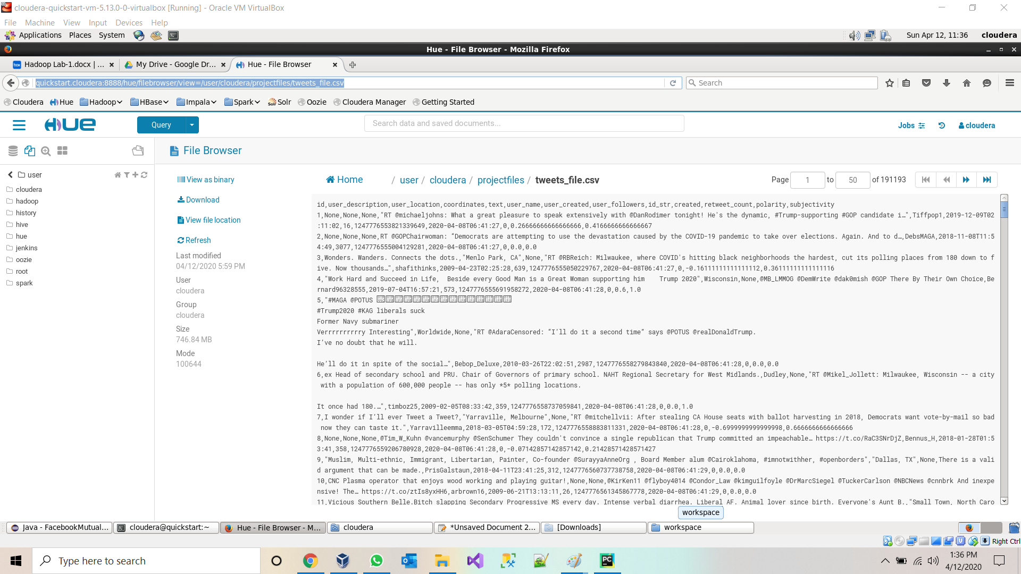

* Querying data from Hive Table:

**Query 1:** 1.Basic query: total number of tweets using aggregate function

* Select count(*) from tweets

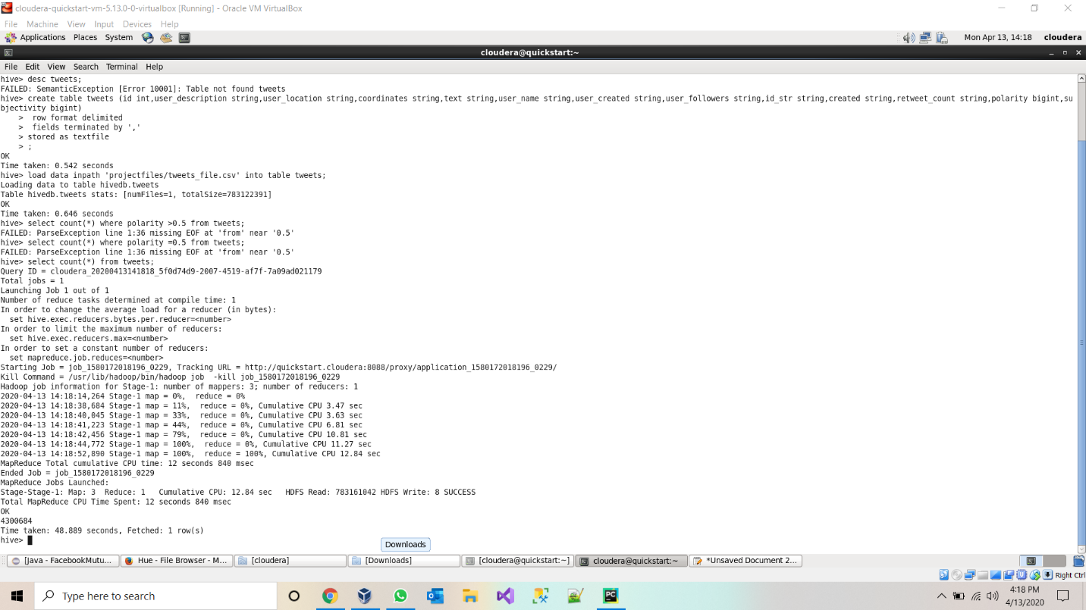

2.Number of positive tweets for republic party using polarity of sentimental analysis

select count(*) from tweets where text like "%Republican%" or text like '%Republics%' or text like '%GOP%' and polarity>0.5;

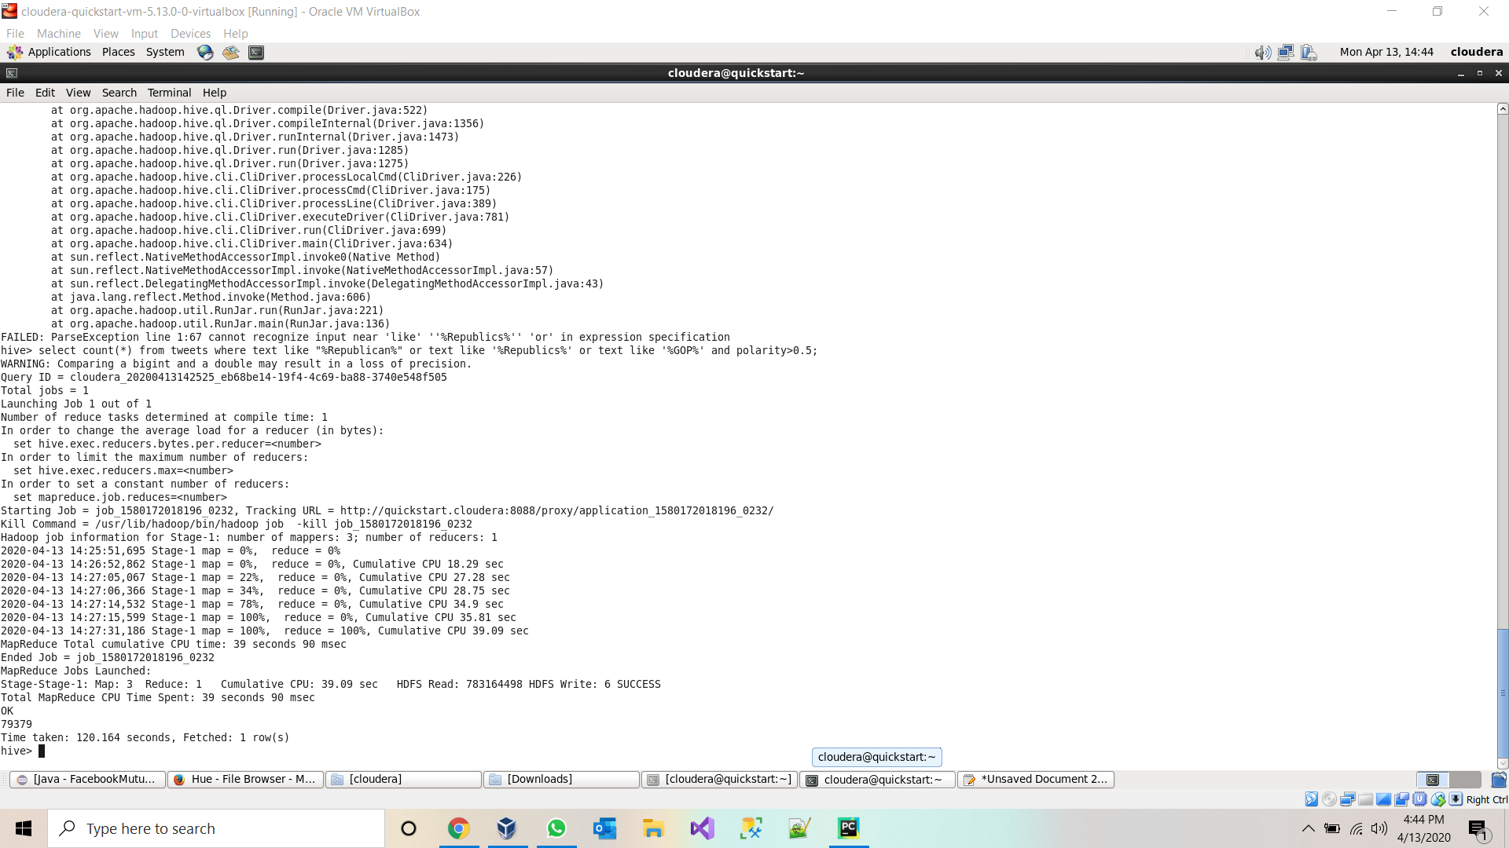

3.Count of positive tweets on democrats using polarity of sentimental analysis object. select count(*) from tweets where text like "%democratic%" or text like "%Democrats%" and polarity>0.5;

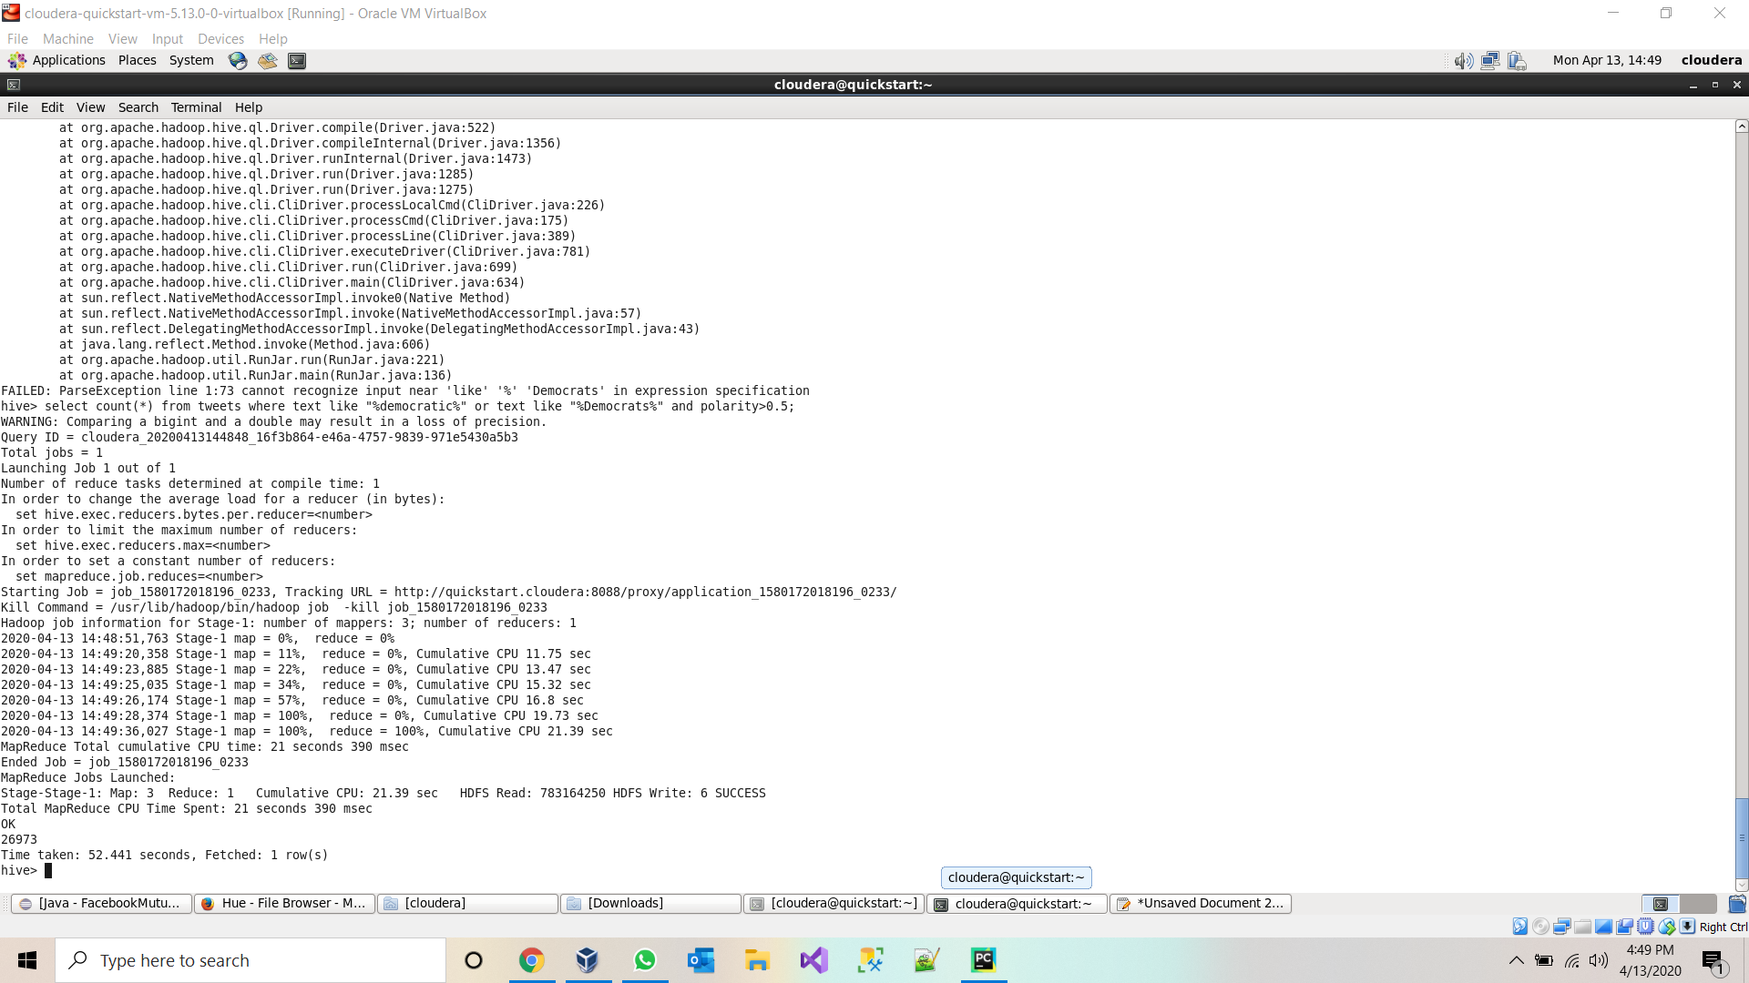

4.Tweets which contains text of US president trump and with positive.

select count(*) from tweets where text like "%trump%" and polarity>0.5;

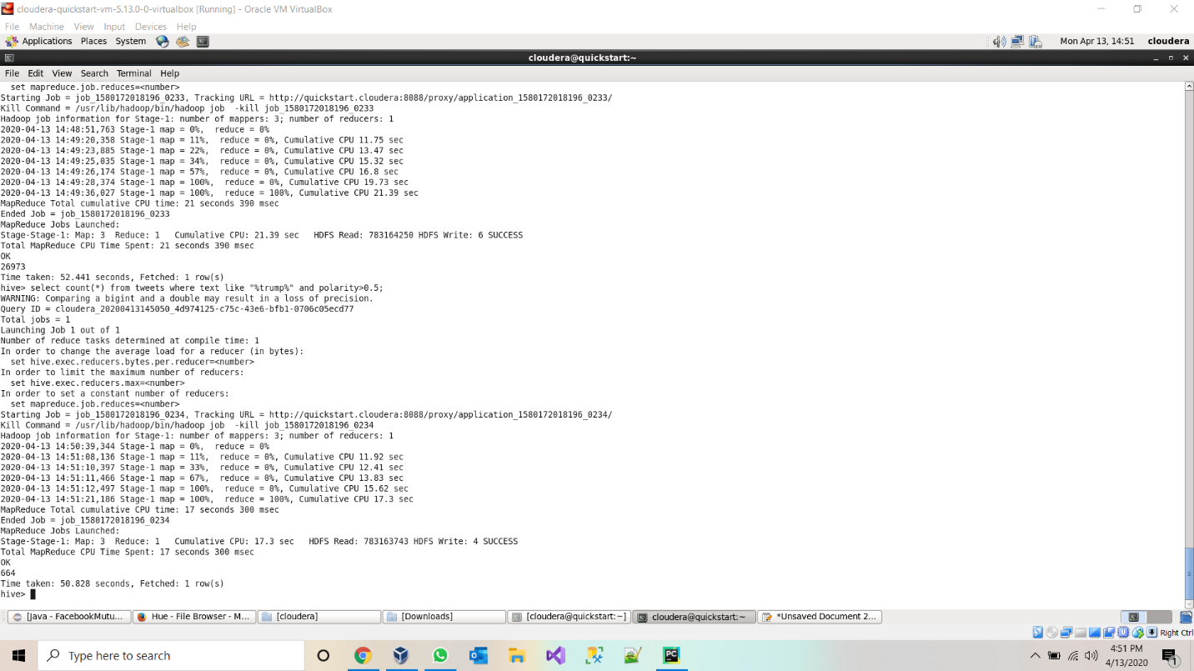

5.Count of tweets which are subjective towards democrats.

select count(*) from tweets where text like "%democratic%" or text like "%Democrats%" and subjectivity=1;

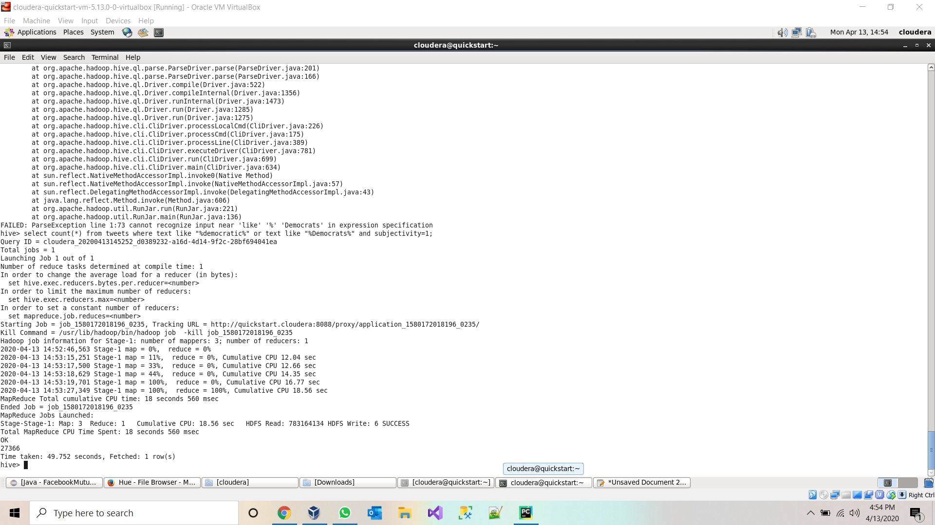

6.Details of tweet which has highest retweet count select text,user_location,polarity,subjectivity,retweet_count as ct from tweets order by ct desc limit 1;

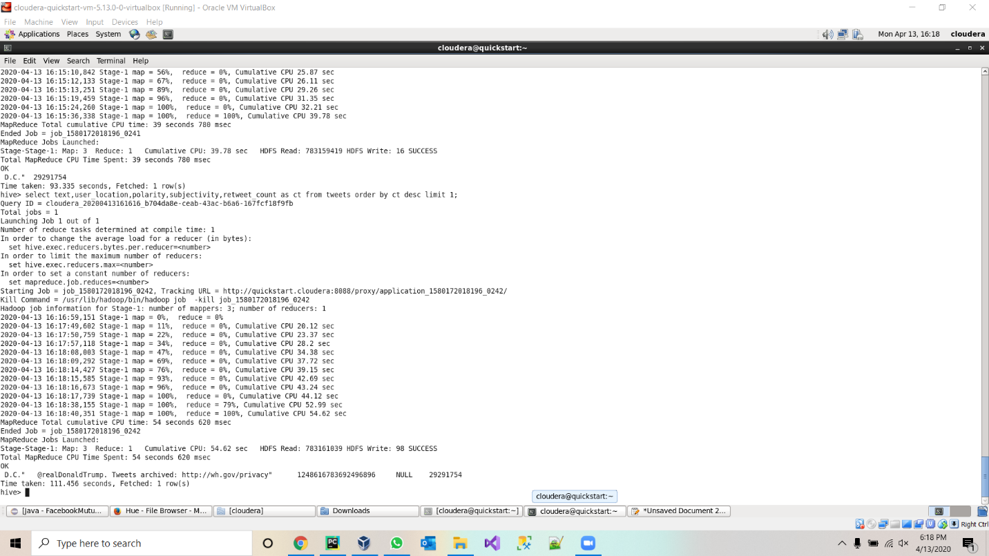

7.User which has highest follower select user_name,user_followers from tweets order by user_followers desc limit 1;

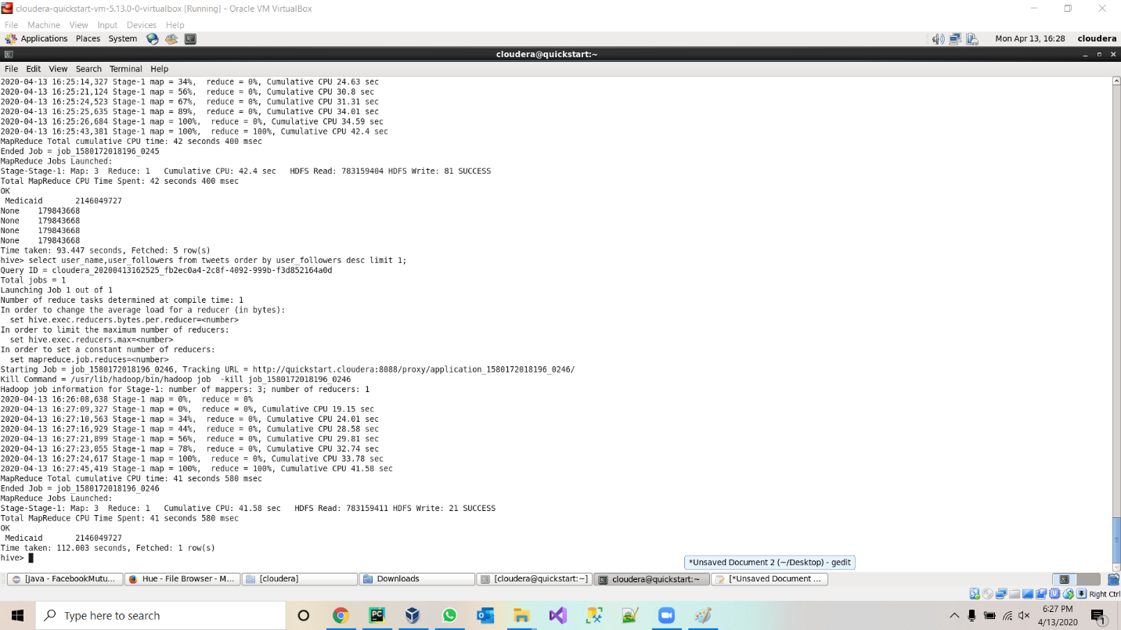

8.Tweet by US president Donald Trump

Select count(*) from tweets where user_name like “%Donald J. Trump%”

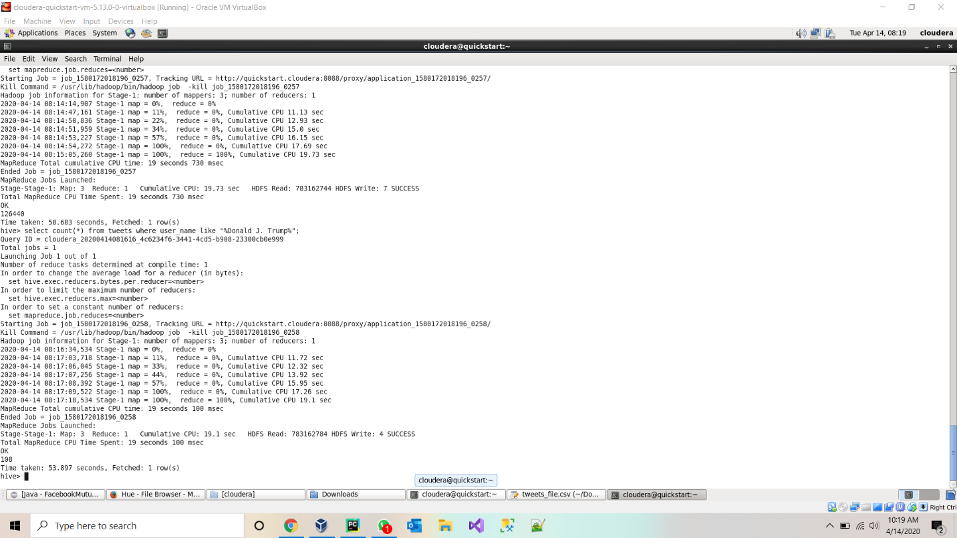

**Project-Management:**

**Implementation-status-report:**

**Work-Completed:**

* Twitter-data batch download & documented his part-Jagadeesh Maroju
* Data Cleanup and project implementation plan & documented his part- Paul Gomes
* HDFS import and Hue Visualization and Hive import & documented his part- Hari Raju
* Hive Queries and report- Praveen Poluri

**Work to be completed:**

* Loading data into solr and implement queries on the data in solr.
* create spark dataframes on CSV file and implement various transformations and actions on dataframes.
* We are also going to implement Spark sql and query the data from dataframe.
* we will implement sentiment analysis on the data.

**References:**

* <https://towardsdatascience.com/twitter-data-collection-tutorial-using-python-3267d7cfa93e>
* <https://hadoop.apache.org/docs/current/hadoop-project-dist/hadoop-hdfs/HDFSCommands.html>
* <https://docs.cloudera.com/HDPDocuments/HDP3/HDP-3.1.0/migrating-data/content/hive_moving_data_from_hdfs_to_hive.html>

**Increment 2:**

**Introduction:**

Collected three million tweets using twitter Streaming API, and saved the collected tweets in JSON file, Implemented Hive queries in HDFS using Hive. Built data frames on top of the JSON file, created temp table view for dataframe created and implemented Spark SQL queries on top of it. Visualized the query results & designed web application to visualize results.

**Dataset Description:**

We are gathering twitter information utilizing Twitter group API utilizing twitter developer account credentials with Republicans and Democrats as watchwords. All tweets are in JSON format. We gathered around 3 million tweets which is around 450 Megabytes. It has different data about a tweet like user_description, user_location, organizes, user_name, user_created, user_followers(follower_id, made), retweet_count, extremity, subjectivity. We are gathering utilizing bunch API and ready to download 4kb every second in which we are separating for watchwords like Democrat supporters, Republican supporters.

URL: [**https://drive.google.com/open?id=18jn55iiWOOTp_1r_dPYG3PGkuSUxWnTp**](https://drive.google.com/open?id=18jn55iiWOOTp_1r_dPYG3PGkuSUxWnTp)

**OBJECTIVE**

* Stream tweets from Twitter (we collected more than 300,000 tweets).
* Write at least 10 analytic queries to explore and understand the collected tweets.
* Create Visualizations on the results.
* Create a web page to view the visualizations.

**TOOLS and Technologies Used**

* Apache Spark
  + Spark Streaming to collect tweets.
  + Spark SQL to store and execute queries.
* Matplot for visualization
* Flask for web application development
* HTML, CSS and Javascript for web application

**IMPLEMENTATION**

* Written a python program to stream the tweets and save them into JSON format which will have details of the tweets.
* The extracted JSON tweets are persisted into the Apache SparkSQL in the form of Views.
* Used Pycharm IDE to write queries and visualize the outputs using tables and charts.
* The web application is developed using HTML, CSS and Java script.

**Libraries used:**

* Matplot for visualizations
* TextBlob to get sentimental score
* Flask for web application

Code for Collecting the Tweets:

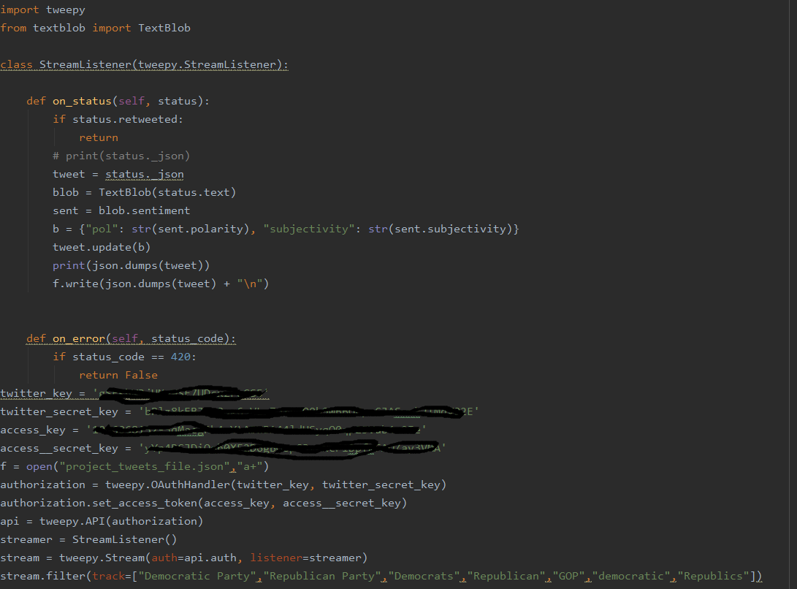

HTML and JavaScript code for UI:

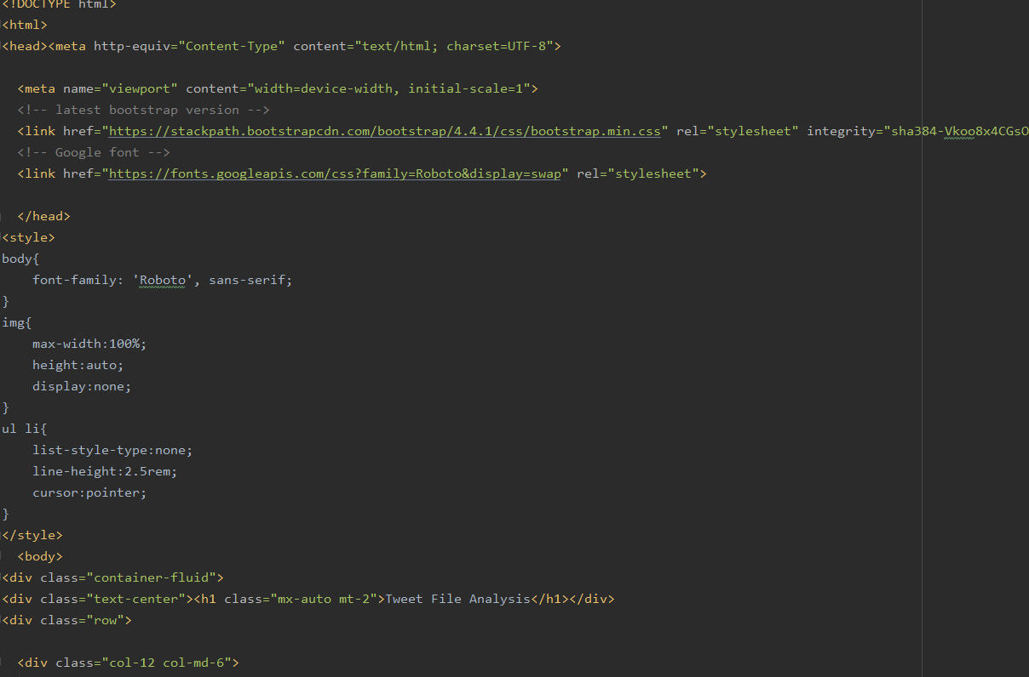

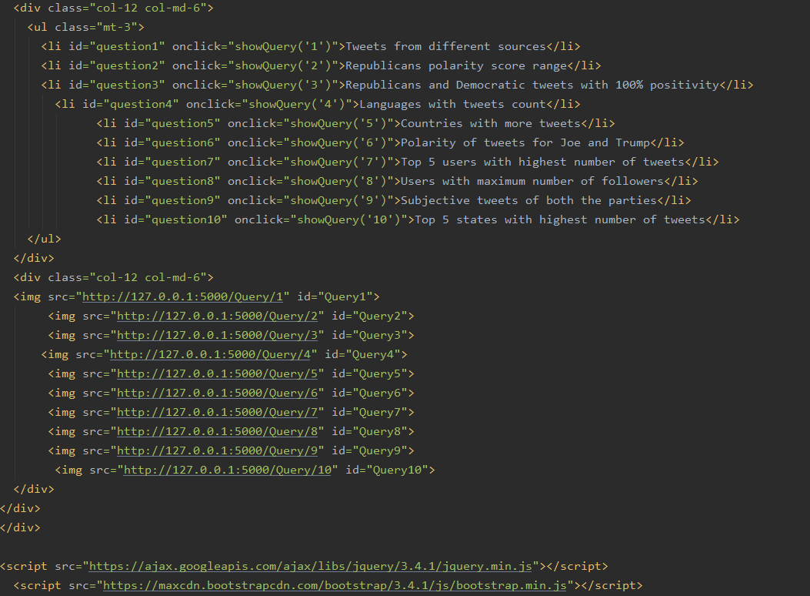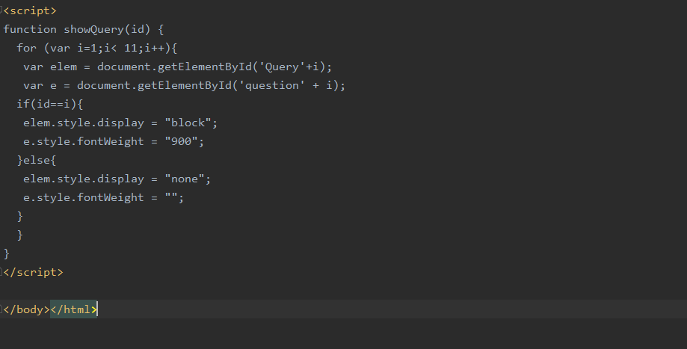

Code For 10 Queries:

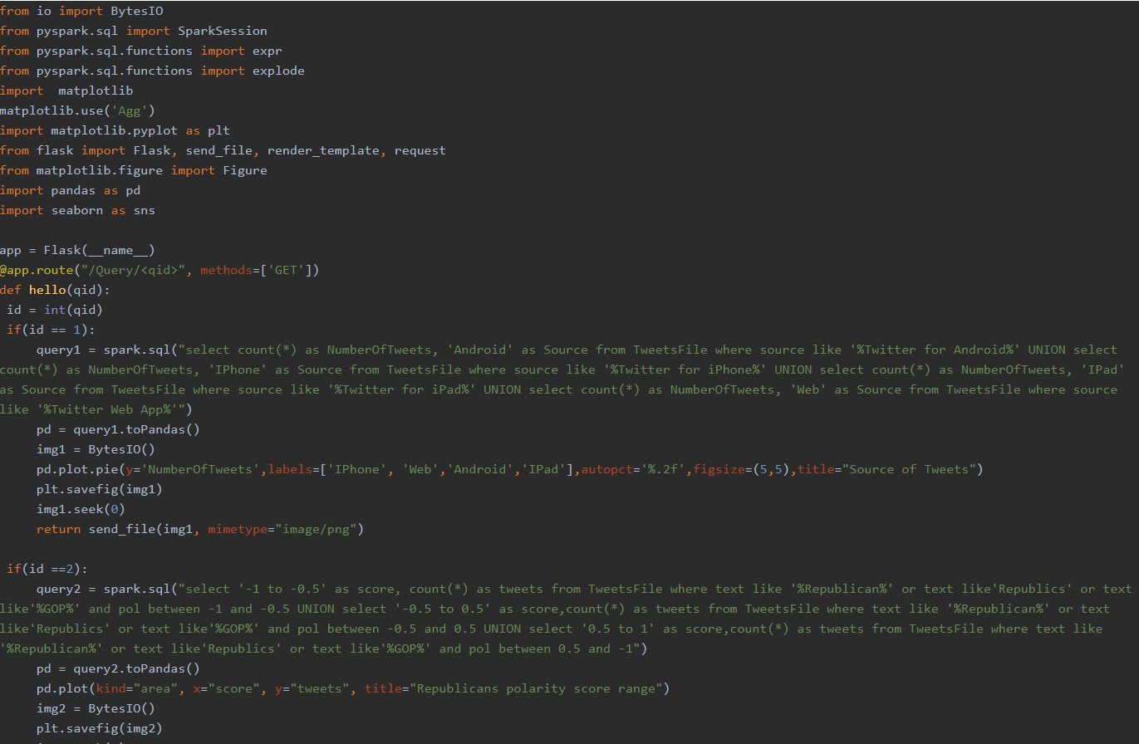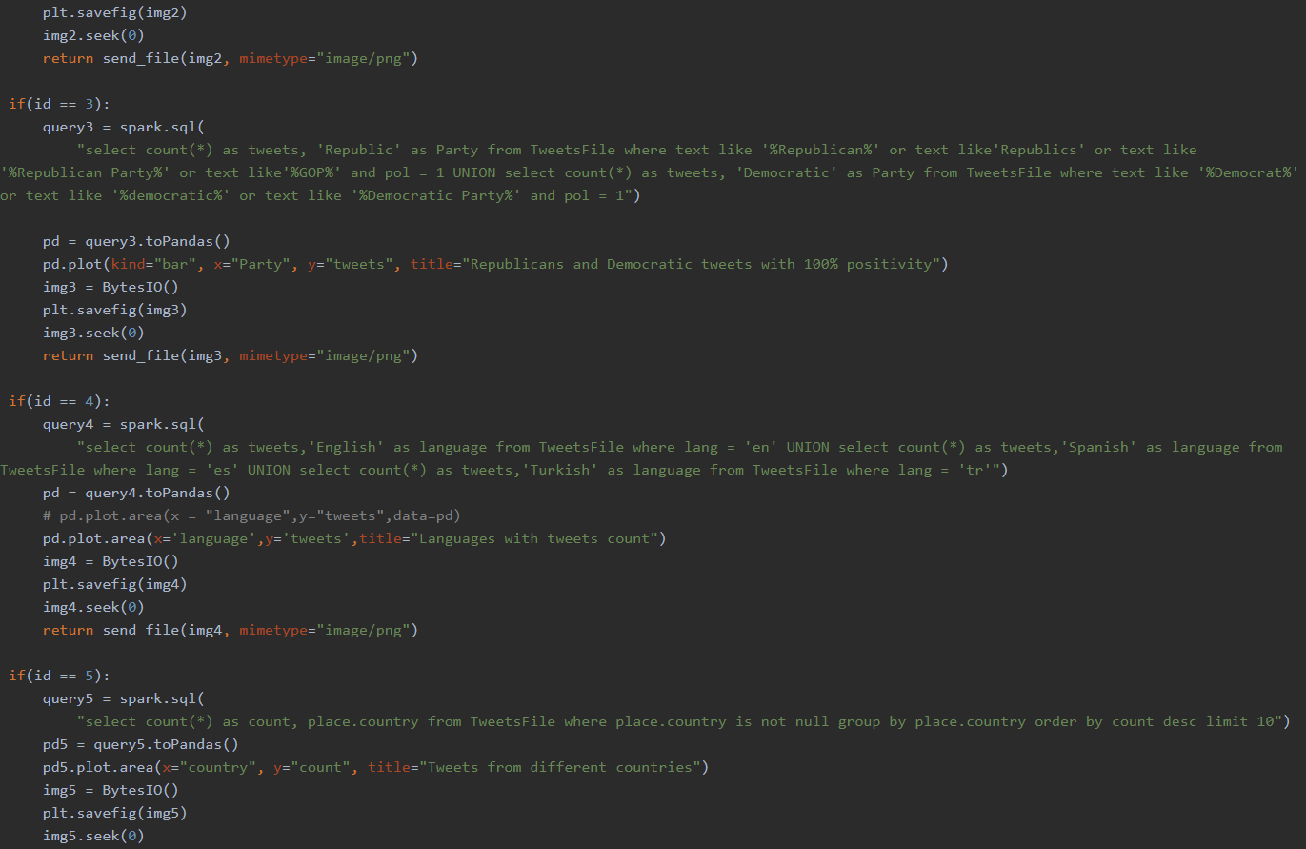

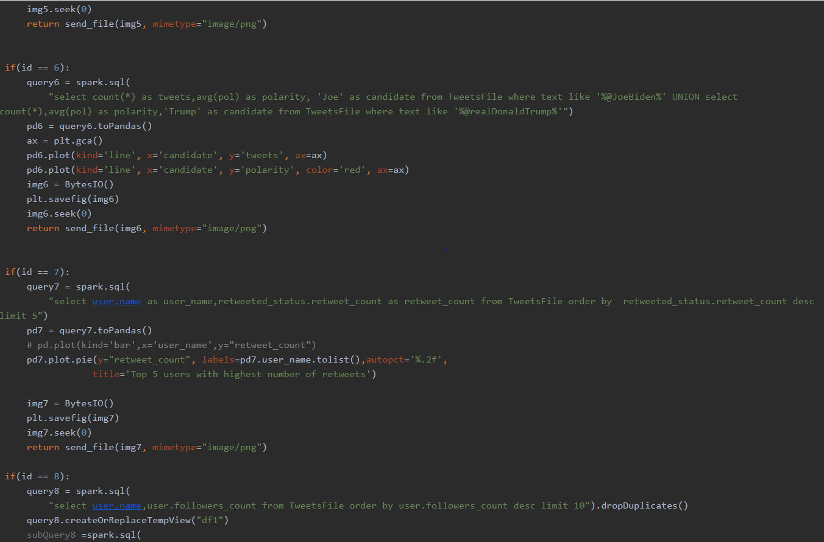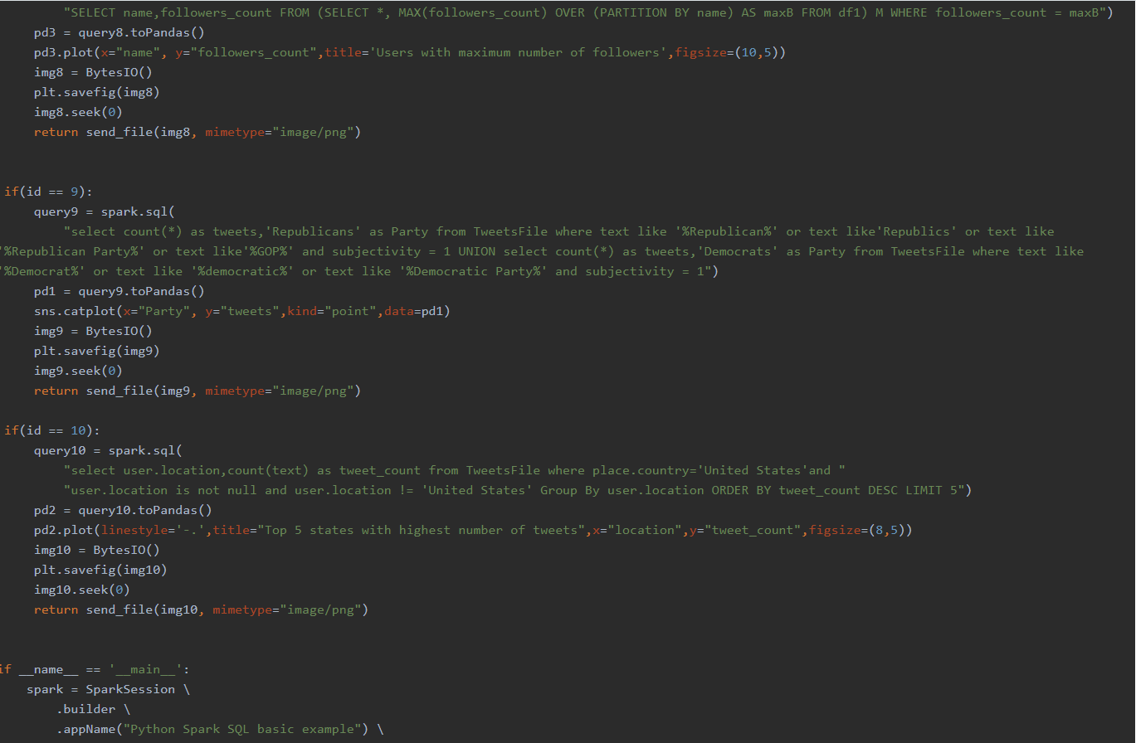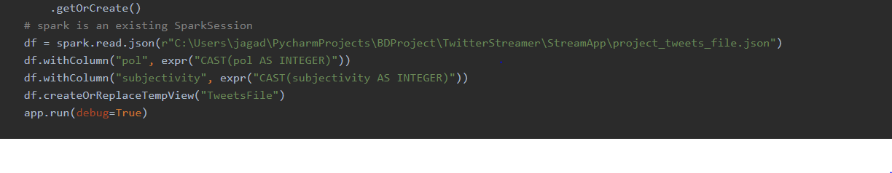

**Query Execution and Results:**

Executed and visualized totally 10 queries.

1). Tweets originated from Different sources using Pie Chart.

Query result in table form :

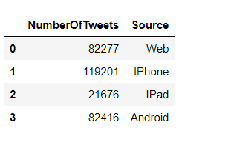

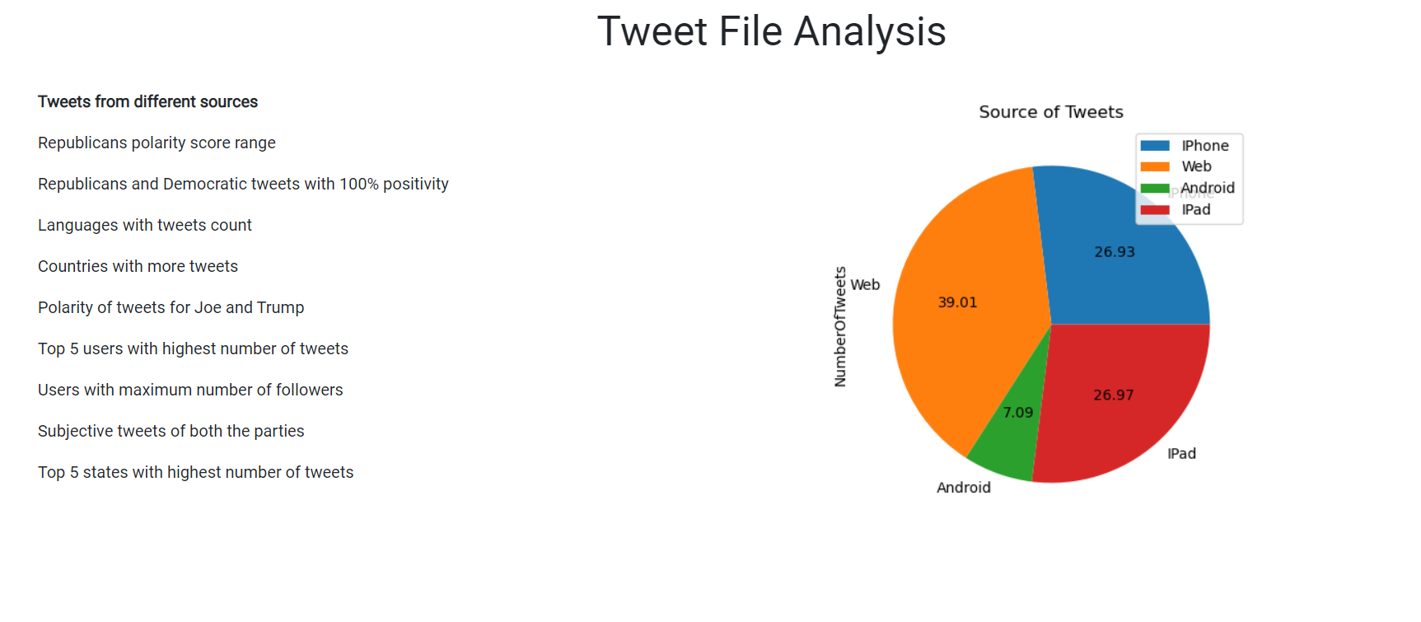

2) Query to display the Republicans with different ranges of polarity score using “Area plot”.

Result:

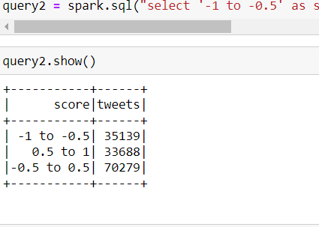

Sentimental Analysis using TextBlob:

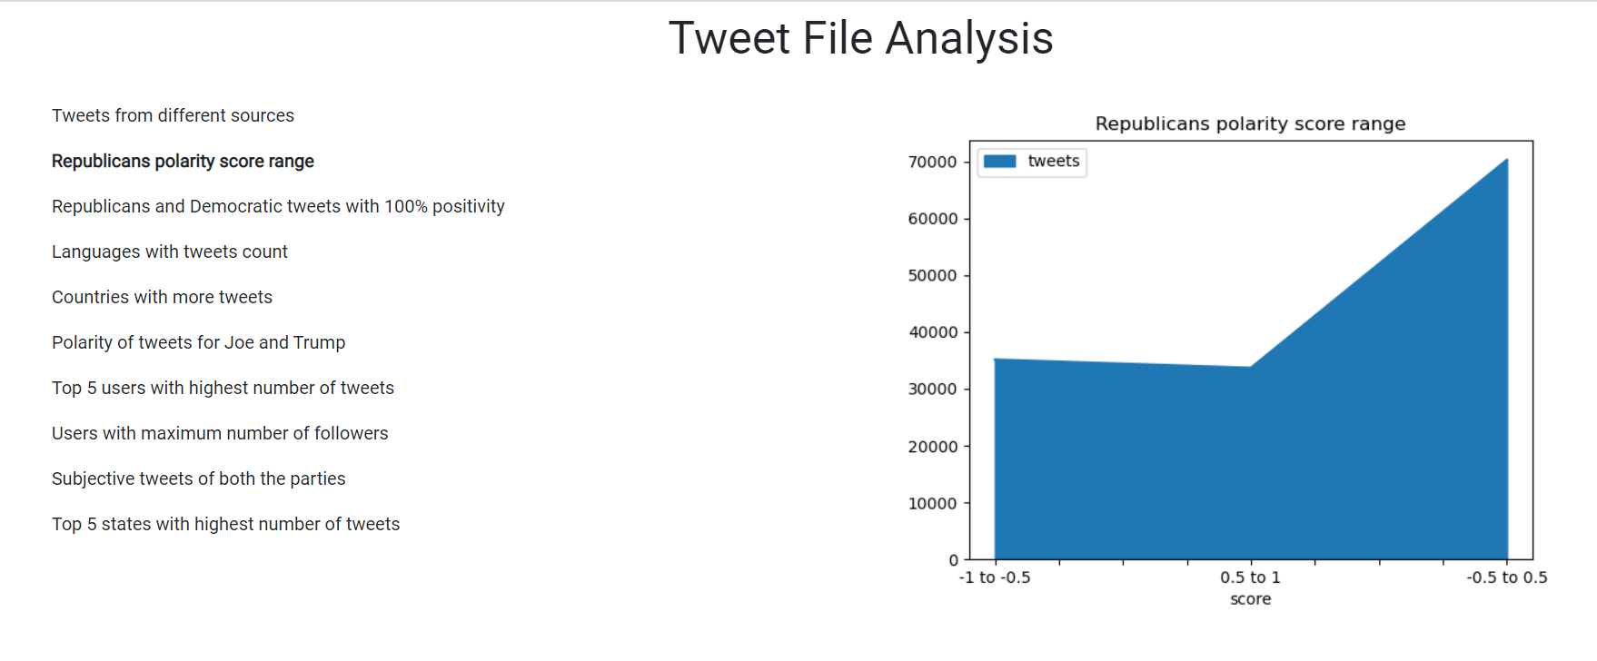

3). Tweets with 100% positivity( i.e polarity = 1) among Republicans and Democratic’s using

“Bar Chart”

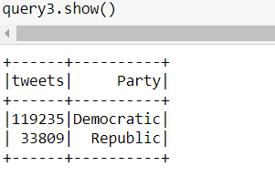

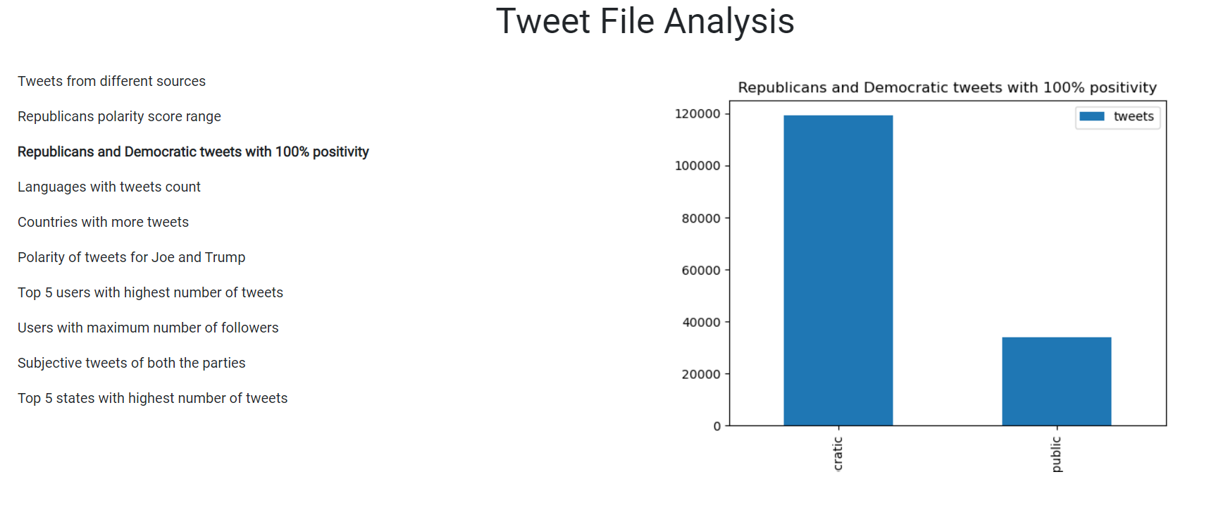

4). Tweets collected from different languages using “Area plot”

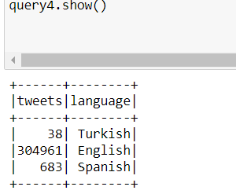

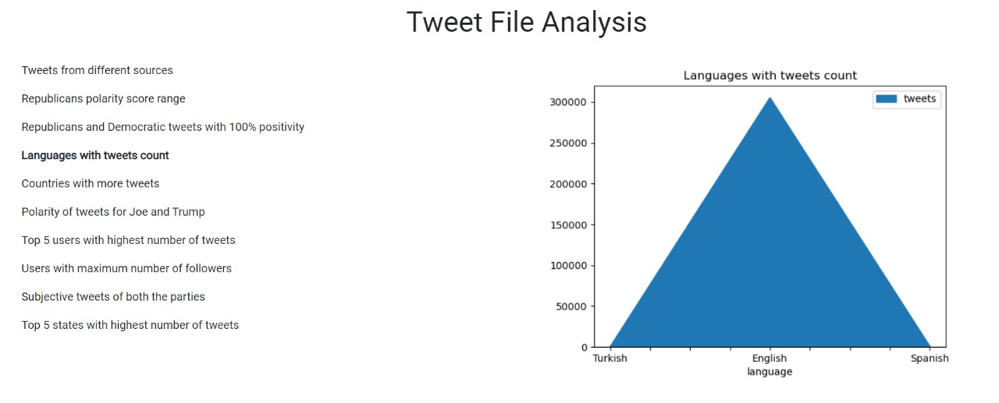

5). Top 5 Countries with Highest number of Tweets using “Area Code”

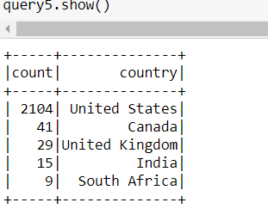

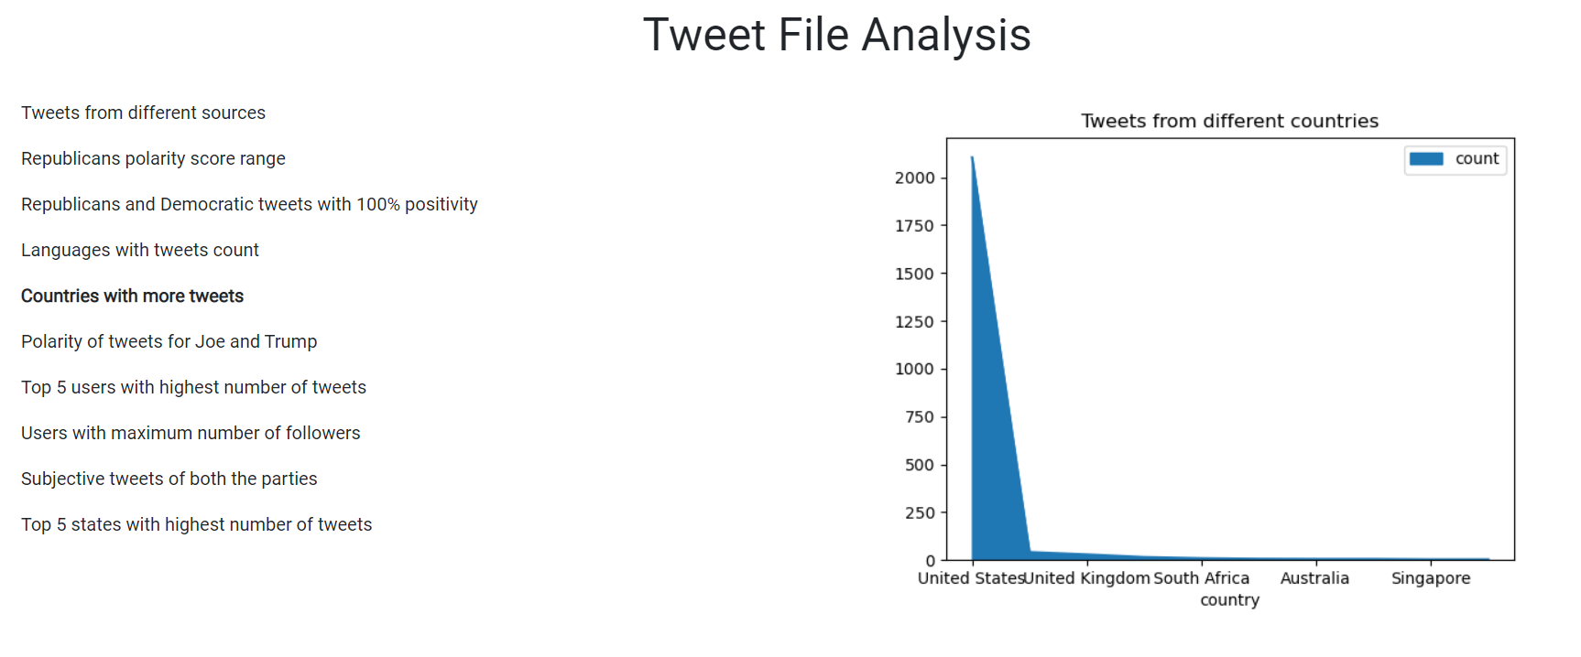

6). Comparing the Polarity of Tweets for Joe and Trump using “Line Graph”

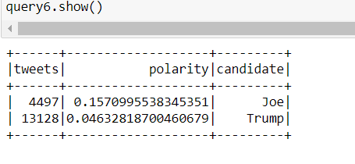

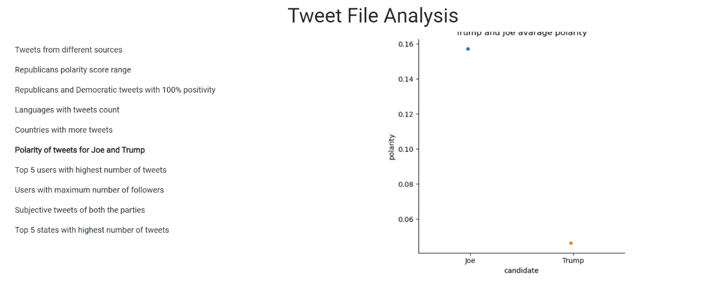

7). Top 5 Users with highest number of tweets from the collected data .

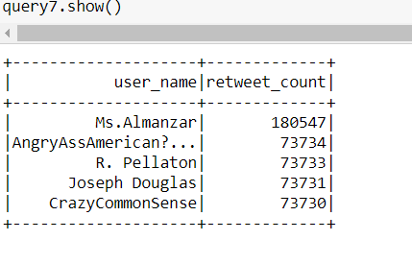

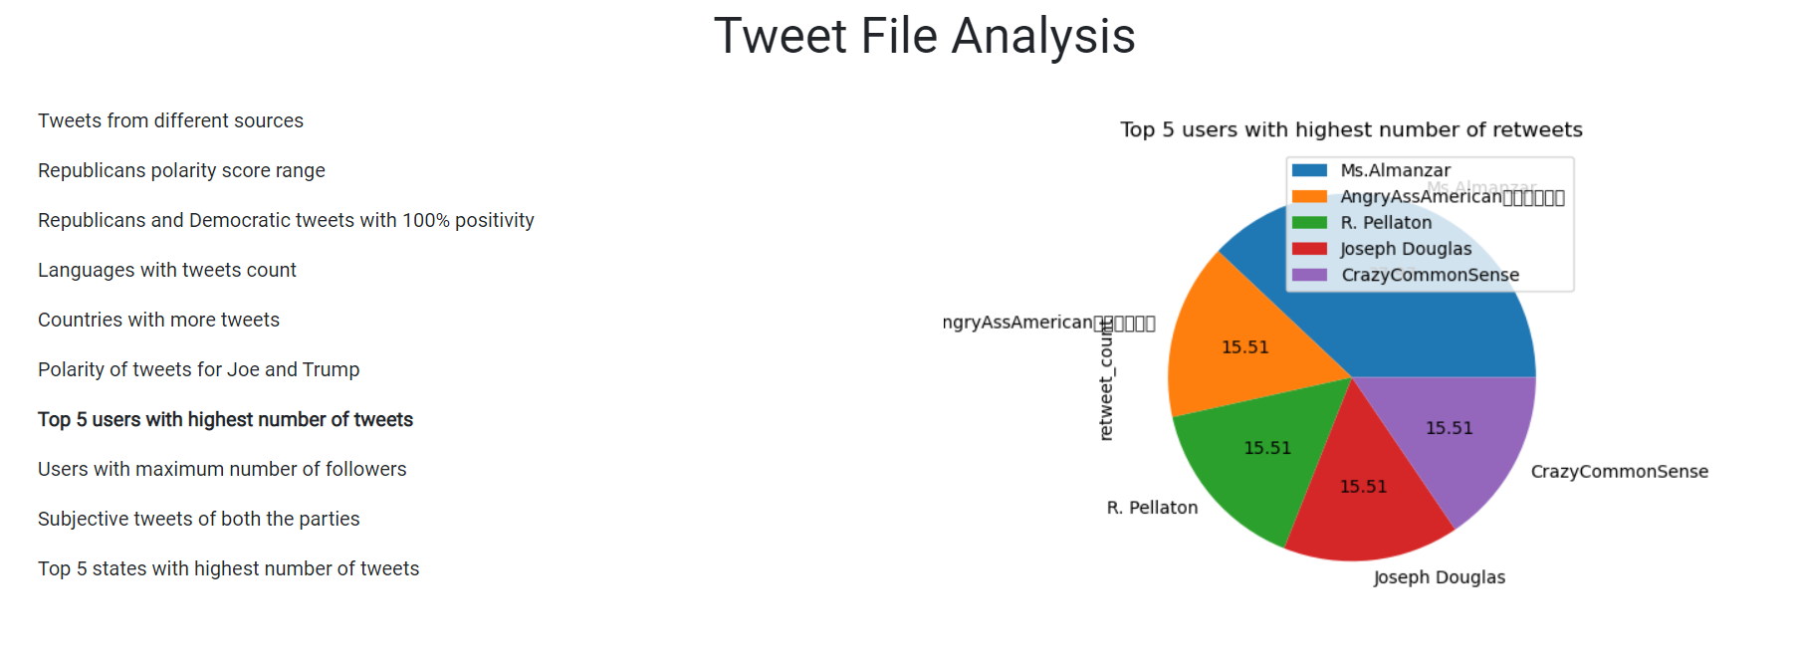

8). Top 5 users with maximum number of followers using “Line Graph”

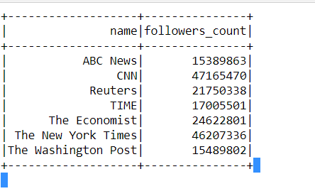

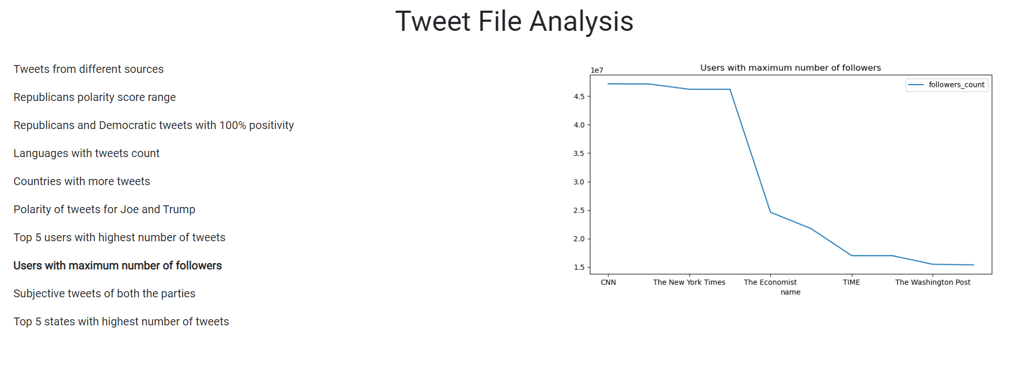

9). Subjective tweets of Democratic and Republicans parties.

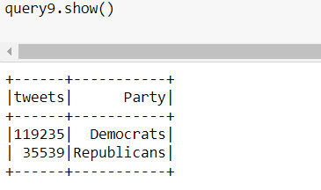

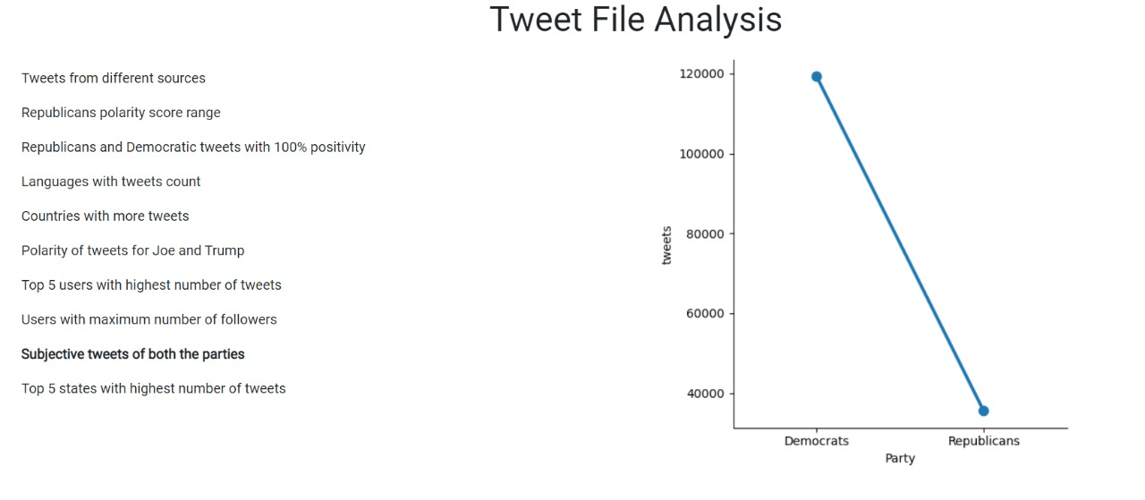

10). Top 5 states in United states with highest number of tweets.

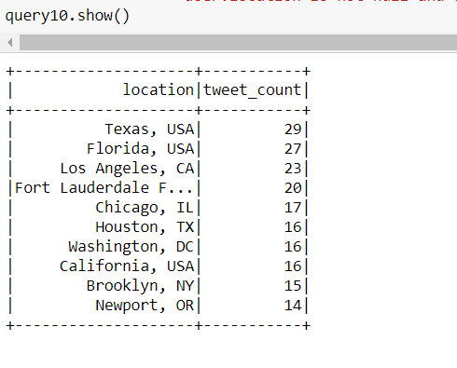

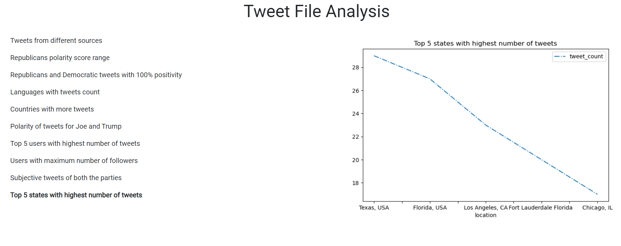

**Project-Management:**

**Implementation-status-report:**

**Work-Completed:**

* Twitter data batch download & documented his part-Jagadeesh Maroju
* Data Cleanup and project implementation plan & documented his part- Paul Gomes
* HDFS import and Hue Visualization and Hive import & documented his part- Hari Raju
* Hive Queries and report- Praveen Poluri
* create spark dataframes on CSV file and implement various transformations and actions on dataframes.
* implemented Spark sql queries and visualized the data queried.
* Implemented Sentimental analysis using textbolb and visualized the results using Flask
* Created a web application to view the visualizations.

**Work to be completed:**

* Loading data into solr and implement queries on the data in solr.

**References:**

<https://spark.apache.org/docs/latest/api/scala/index.html#org.apache.spark.package>

<https://spark.apache.org/docs/latest/api/python/index.html>